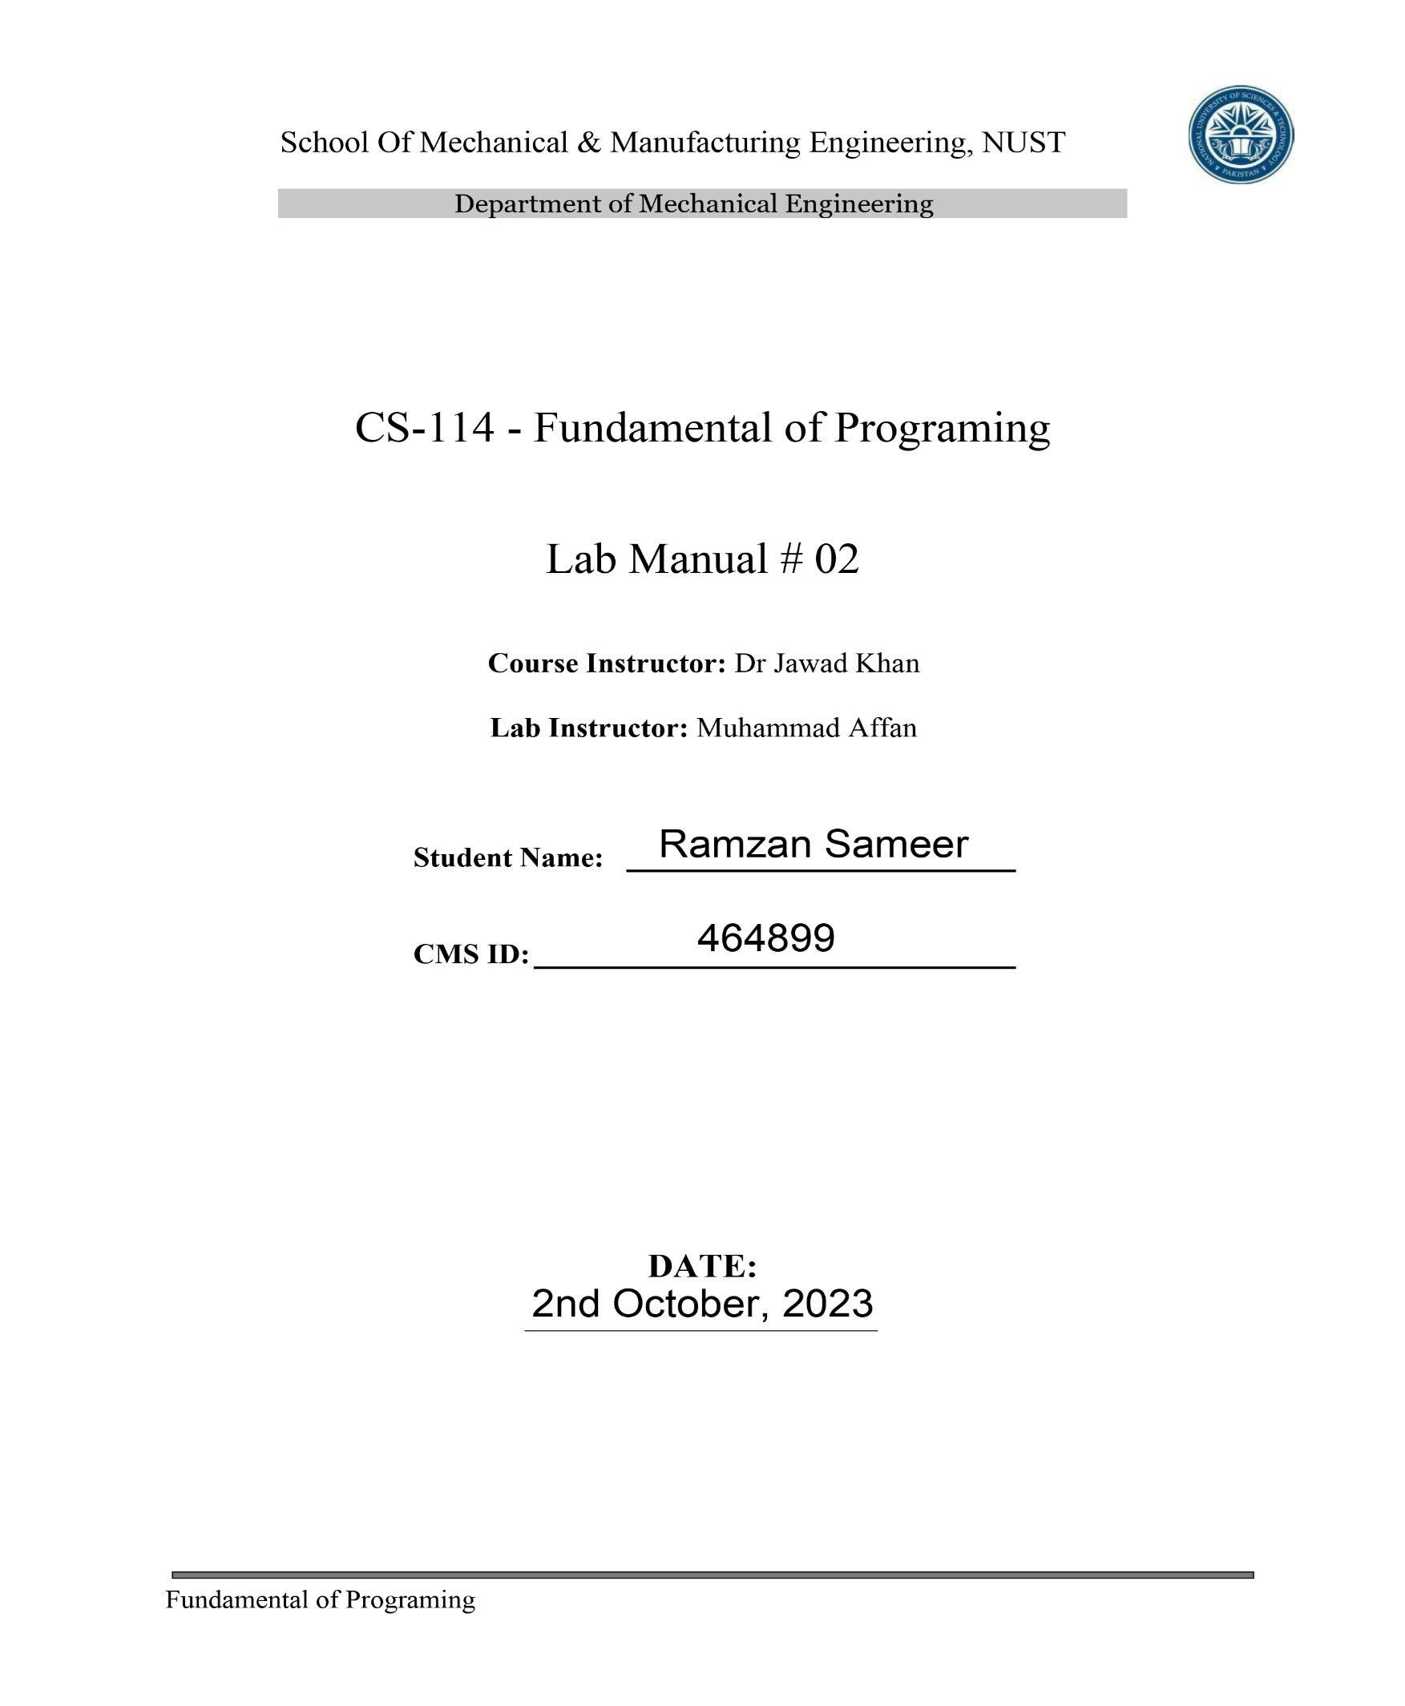

Q1. Create a program that takes a student's score as input and assigns a grade based on predefined criteria using logical operators (e.g., A, B, C, D, F). A-Grade: 90-100 Marks B-Grade: 75-90 Marks C-Grade: 60-75 Marks D-Grade: 45-60 Marks F-Grade: 0-45 Marks

Code and Result:

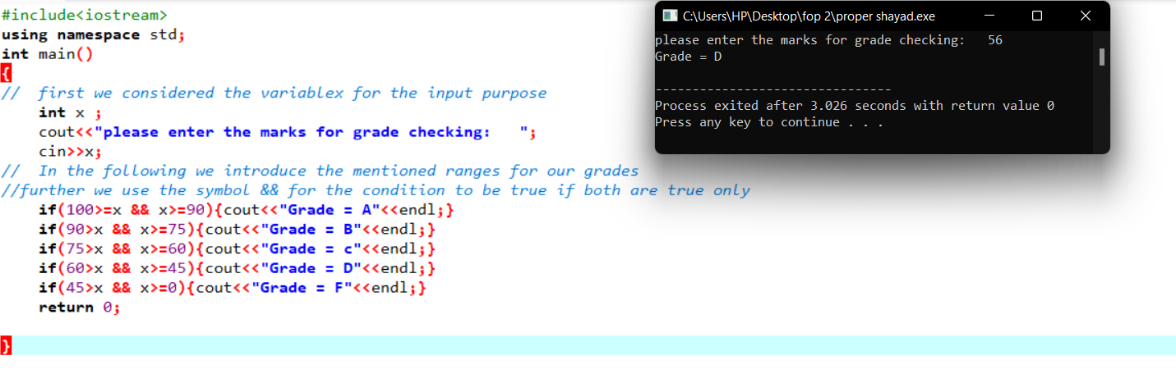

Q2. Write a program that takes an integer as input and determines if it is both even and divisible by 5.

Code and Result:

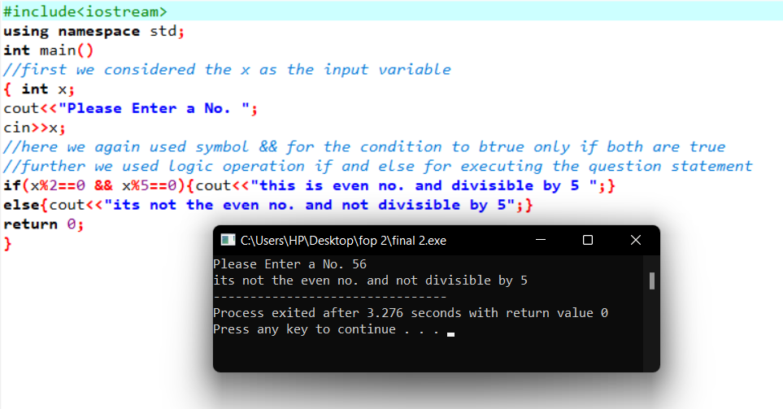

Q3. Create a C++ program that checks if a user-provided year is a leap year.

Code and Result:

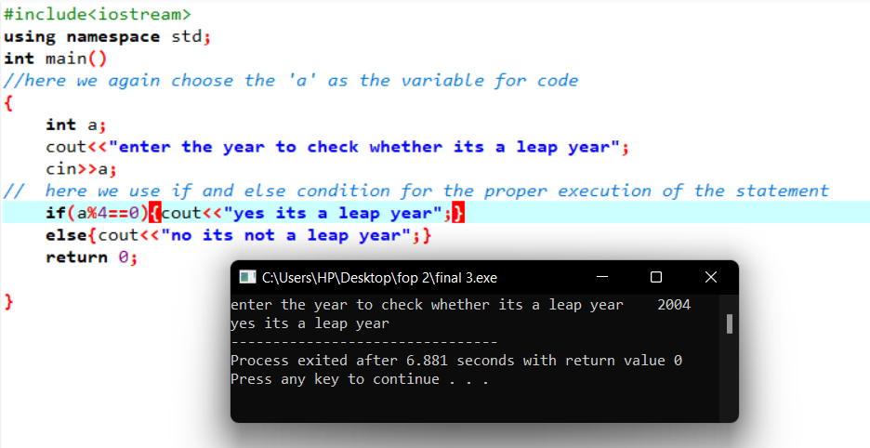

Q4. Create a C++ program that determines if a student is eligible for a scholarship based on their GPA (must have GPA >= 3.5) and attendance (must have attended at least 80% of classes).

Code and result:

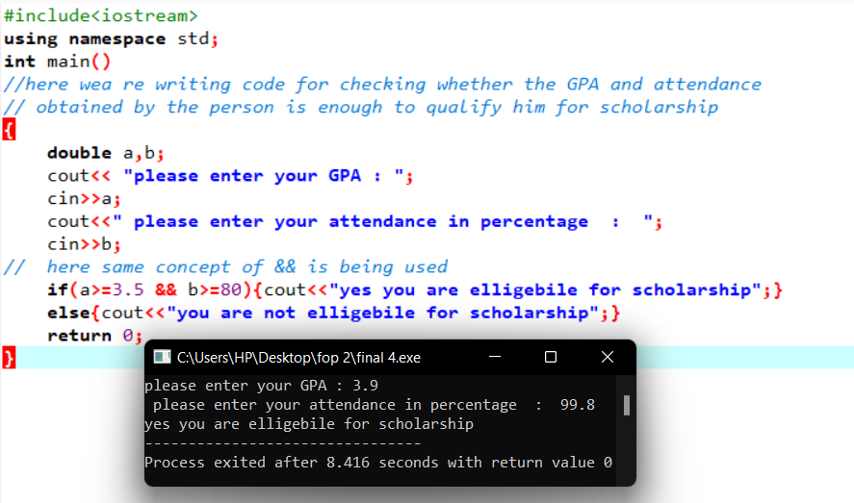

Q5. Write a program that checks if a given character is a vowel (a, e, i, o, u) or a consonant using logical operators.

Code and result:

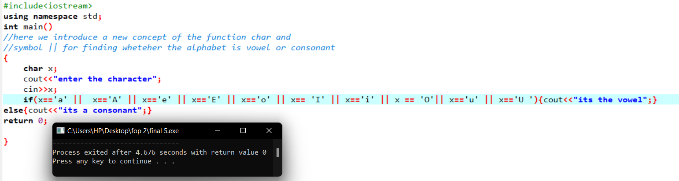

Thank You!